Quantifying the Paleocene–Eocene Carbon Isotope Excursion at ODP Site 1262: Statistical Characterization, Change-Point Analysis, and Model Robustness
Abstract
The Paleocene–Eocene Thermal Maximum (PETM) was a major episode of global warming and carbon-cycle perturbation, characterized by a prominent negative carbon isotope excursion (CIE). This study statistically characterizes the bulk carbonate carbon isotope record from Ocean Drilling Program (ODP) Site 1262 using the published dataset archived by Barnet et al. (2019) in PANGAEA. The analysis combines data quality assessment, baseline sensitivity testing, change-point detection, segmented linear regression, and residual diagnostics.
The dataset comprises 4,364 observations, of which 247 fall within the 56.30–55.65 Ma interval selected for segmented regression. A pre-excursion baseline median δ¹³C value of 2.836‰ was calculated from 74 observations between 56.30 and 56.10 Ma. The observed minimum of 0.187‰ occurs at 55.878 Ma, yielding a baseline-to-minimum difference of 2.649‰. Alternative baseline intervals produced differences of 2.688‰ and 2.735‰.
A three-segment linear model identified boundaries between observations at 55.932–55.905 Ma and 55.870–55.867 Ma. The model provided a lower residual sum of squares than the corresponding piecewise-constant model. However, substantial positive residual autocorrelation persisted, and the first breakpoint coincided with a 27 kyr sampling gap. The second breakpoint was sensitive to the minimum segment-size constraint.
These findings demonstrate the utility of combining direct isotope measurements with exploratory statistical segmentation while highlighting the importance of sampling resolution, model assumptions, and robustness testing when interpreting rapid paleoclimate transitions.
Keywords: Paleocene–Eocene Thermal Maximum; carbon isotope excursion; ODP Site 1262; segmented regression; change-point analysis; paleoclimate statistics.

1. Introduction
The Paleocene–Eocene Thermal Maximum represents one of the most intensively investigated episodes of rapid environmental change during the early Cenozoic. The event is associated with pronounced global warming, oceanographic changes, and a major perturbation of the global carbon cycle.
One of the defining geochemical features of the PETM is a negative carbon isotope excursion recorded in marine and terrestrial archives. This excursion is commonly interpreted as evidence for the introduction of isotopically light carbon into the ocean–atmosphere system, although the magnitude and timing of the recorded response can vary among archives.
Marine carbonate isotope records provide important evidence for reconstructing the evolution of this event. However, quantitative interpretation requires careful consideration of sampling resolution, age-model uncertainties, analytical variability, and the statistical methods used to identify changes in the isotope trajectory.
ODP Site 1262, situated on Walvis Ridge in the South Atlantic Ocean, provides a well-studied marine sedimentary record spanning the Paleocene–Eocene transition. Published isotope measurements from this site offer an opportunity to investigate the PETM carbon isotope excursion through reproducible statistical methods.
The present study aims to characterize the observed δ¹³C excursion and evaluate the statistical structure of the isotope record using a transparent, reproducible workflow.
The specific objectives are to:
- Assess the quality and temporal structure of the published isotope dataset.
- Quantify the observed δ¹³C excursion using a defined pre-excursion baseline.
- Evaluate sensitivity to alternative baseline intervals.
- Identify changes in the isotope trajectory using piecewise-constant and piecewise-linear models.
- Examine breakpoint stability and residual autocorrelation to assess the limitations of the fitted models.
2. Data and Methods
2.1. Dataset
Bulk carbonate δ¹³C and δ¹⁸O measurements were obtained from the published ODP Site 1262 dataset archived by Barnet et al. (2019) in PANGAEA (DOI: 10.1594/PANGAEA.903507).
The dataset contains 4,364 rows and includes sediment depth, bulk carbonate δ¹³C, bulk carbonate δ¹⁸O, age, and reference information.
Age values reported in thousands of years before present were converted to millions of years (Ma) by division by 1,000.
The original values were retained during data quality assessment. Observations with missing δ¹³C values were excluded only from analyses requiring carbon isotope measurements.
2.2. Data quality assessment
Data quality assessment included examination of missing values, repeated sediment depths, and age–depth consistency.
One missing δ¹³C measurement and three missing δ¹⁸O measurements were identified. Repeated sediment-depth values were retained rather than automatically averaged because identical reported depths do not necessarily represent equivalent analytical replicates.
A local age–depth reversal of approximately 1 kyr was identified and documented without modifying the original age assignments.
2.3. Carbon isotope excursion quantification
The pre-excursion baseline was defined using observations between 56.30 and 56.10 Ma.
The median δ¹³C value was selected as the baseline statistic to reduce sensitivity to individual extreme observations.
The observed excursion magnitude was calculated as the difference between the baseline median and the minimum measured δ¹³C value within the PETM-focused interval.
Baseline sensitivity was evaluated using two additional intervals: 56.30–56.15 Ma and 56.30–56.20 Ma.
The resulting values represent baseline-to-observed-minimum differences rather than a complete estimate of uncertainty in the global PETM carbon isotope excursion.
2.4. Change-point and segmented regression analysis
Statistical segmentation was performed using δ¹³C observations spanning 56.30–55.65 Ma.
Piecewise-constant models were initially fitted by minimizing within-segment residual sums of squares.
Subsequently, a discontinuous piecewise-linear model was fitted using three independently estimated linear segments.
Two breakpoints were selected by exhaustive minimization of the combined residual sum of squares, subject to a minimum number of observations per segment.
The fitted regression slopes were converted from per Ma to per kyr and interpreted in the forward geological-time direction.
2.5. Model comparison and validation
Four candidate models were compared: a single constant mean, three constant segments, a single linear regression, and three linear segments.
Relative model performance was assessed using residual sum of squares and an exploratory Bayesian Information Criterion (BIC), with parameter counts incorporating the fitted coefficients and an approximate penalty for breakpoint selection.
Residual autocorrelation was assessed using lag-1 correlation coefficients. Breakpoint sensitivity was evaluated by varying the minimum segment size between 10 and 30 observations.
Because the isotope observations are irregularly spaced and serially dependent, the BIC comparison and breakpoint estimates were interpreted as exploratory rather than definitive statistical inference.
3. Results
3.1. Dataset characteristics and quality assessment
The ODP Site 1262 dataset comprises 4,364 observations, including bulk carbonate δ¹³C and δ¹⁸O measurements, sediment depths, and corresponding age assignments. Initial data quality assessment identified one missing δ¹³C measurement and three missing δ¹⁸O measurements. A total of 98 observations were associated with 49 repeated sediment-depth values. A minor age–depth reversal of approximately 1 kyr was also identified. These characteristics are summarized in Table 1.
The temporal variations in bulk carbonate δ¹³C and δ¹⁸O are illustrated in Figure 1. The carbon isotope record exhibits a prominent negative excursion near the Paleocene–Eocene transition, whereas the oxygen isotope record provides complementary information on isotopic variability across the studied interval. The PETM-focused interval was selected for subsequent quantitative analysis.

Table 1: Dataset characteristics and quality-control summary
Parameter | Result
Total observations | 4,364
Missing δ¹³C | 1
Missing δ¹⁸O | 3
PETM-focused regression observations | 247
Repeated-depth observations | 98
Distinct repeated depths | 49
Identified age-depth reversal | 1 kyr

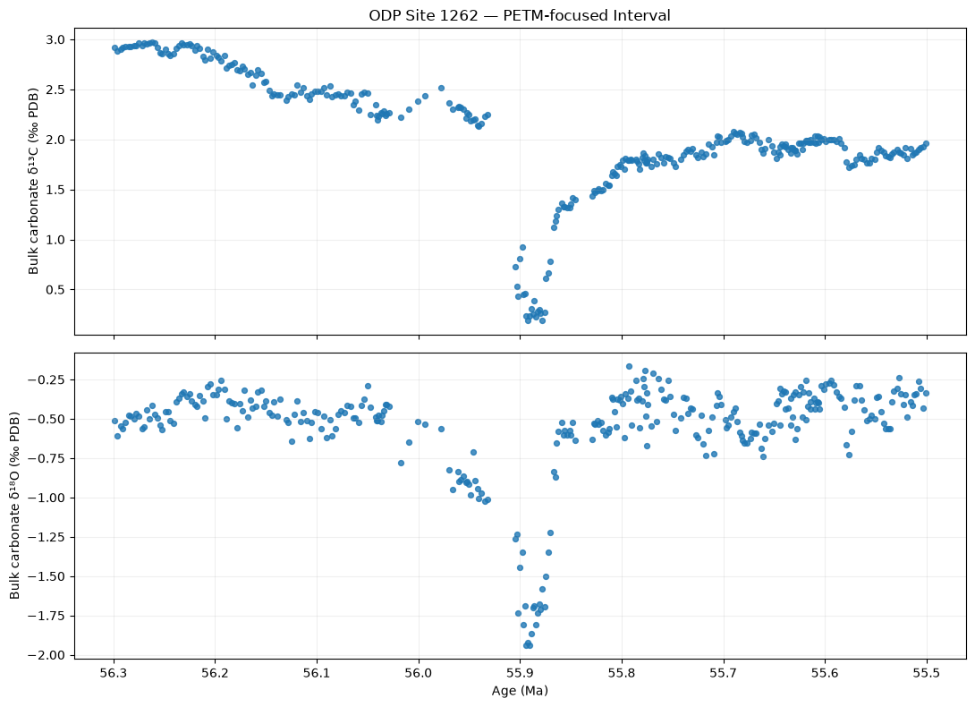
Figure 1: Bulk carbonate δ¹³C and δ¹⁸O records at ODP Site 1262

3.2. Magnitude and baseline sensitivity of the carbon isotope excursion
The bulk carbonate δ¹³C record between 56.30 and 55.50 Ma reveals a pronounced negative excursion, as illustrated in Figure 2. The pre-excursion baseline, defined between 56.30 and 56.10 Ma, contains 74 observations and has a median δ¹³C value of 2.836‰. The minimum observed δ¹³C value of 0.187‰ occurs at 55.878 Ma and a sediment depth of 139.820 m. The resulting baseline-to-minimum difference is 2.649‰.
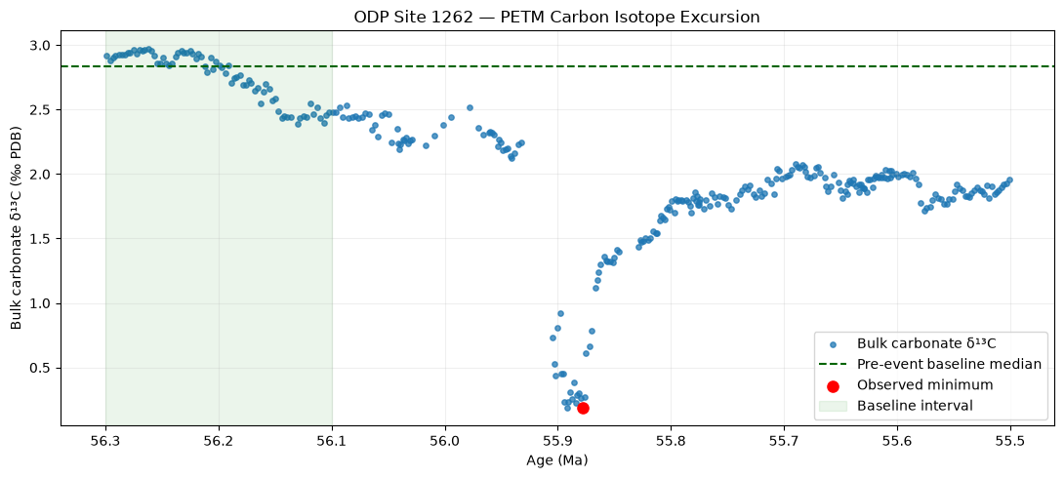
Figure 2: PETM carbon isotope excursion and baseline sensitivity
To assess the sensitivity of this estimate to baseline selection, two additional intervals were examined. The 56.30–56.15 Ma interval yielded a median δ¹³C value of 2.875‰ and a baseline-to-minimum difference of 2.688‰, whereas the 56.30–56.20 Ma interval yielded corresponding values of 2.922‰ and 2.735‰. The results of the baseline sensitivity analysis are summarized in Table 2.
Table 2: PETM carbon isotope excursion magnitude and baseline sensitivity
Baseline interval (Ma) | n | Median δ¹³C (‰) | Difference from minimum (‰)
56.30–56.10 | 74 | 2.836 | 2.649
56.30–56.15 | 58 | 2.875 | 2.688
56.30–56.20 | 38 | 2.922 | 2.735

The calculated baseline-to-minimum difference therefore varies by 0.086‰ across the three tested baseline definitions. This variation indicates limited sensitivity to the selected, overlapping baseline intervals, although it does not represent a formal uncertainty estimate for the excursion magnitude.
A 27 kyr sampling gap between 55.932 and 55.905 Ma occurs adjacent to the sharp excursion and is highlighted in Figure 2. The gap limits the temporal resolution available for characterizing the transition.
3.3. Segmented linear regression of the carbon isotope record
A three-segment piecewise-linear regression model was fitted to 247 bulk carbonate δ¹³C observations spanning 56.30–55.65 Ma. The observed values and independently fitted regression lines are presented in Figure 3, while the segment-specific regression results are summarized in Table 3.
Table 3: Segmented linear regression results
Segment | n | Age range (Ma) | Forward-time slope (‰/kyr)
Older | 125 | 56.299–55.932 | −0.00233
Middle | 22 | 55.905–55.870 | −0.00418
Younger | 100 | 55.867–55.650 | +0.00333

The older segment (n = 125; 56.299–55.932 Ma) exhibits a fitted decline in δ¹³C toward younger ages of −0.00233‰/kyr. The middle segment (n = 22; 55.905–55.870 Ma) shows a steeper negative trend of −0.00418‰/kyr. In contrast, the younger segment (n = 100; 55.867–55.650 Ma) exhibits an increasing trend of +0.00333‰/kyr.
The model identifies two boundaries, bracketed by observations at 55.932–55.905 Ma and 55.870–55.867 Ma, respectively (Figure 3). The first boundary coincides with the previously identified 27 kyr sampling gap, preventing precise determination of the timing or rate of the associated transition.
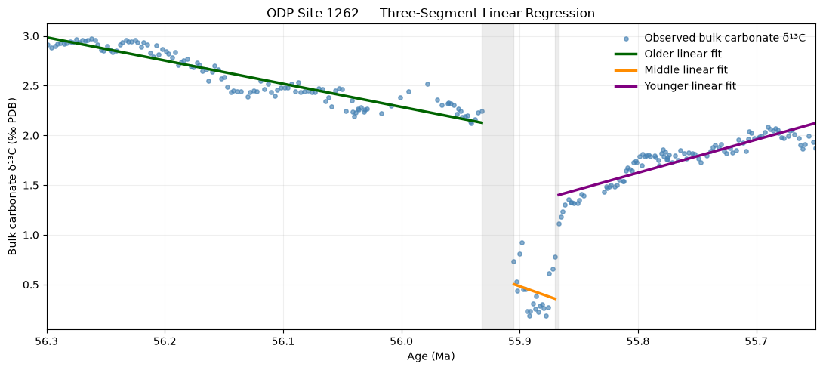
Figure 3: Three-segment linear regression of the PETM δ¹³C record
3.4. Comparison of statistical models
Four candidate models were evaluated to assess differences in descriptive fit and model complexity: a single constant-mean model, a three-segment piecewise-constant model, a single linear regression, and a three-segment piecewise-linear regression.
The three-segment linear model produced the lowest residual sum of squares (RSS = 3.038), compared with 14.968 for the three-segment constant model, 67.020 for the single linear regression, and 116.292 for the single constant-mean model.
The three-segment linear model also yielded the lowest exploratory Bayesian Information Criterion (BIC = −1042.32). The three-segment constant model, single linear regression, and constant-mean model yielded BIC values of −664.91, −311.17, and −180.55, respectively.
The comparative BIC values are illustrated in Supplementary Figure S1, and the complete model-comparison statistics are reported in Supplementary Table S1.
These results indicate that the three-segment linear model provides the closest descriptive fit among the four candidate models examined, although the comparison does not establish that three segments represent a uniquely optimal geological model.
3.5. Residual diagnostics and breakpoint robustness
Residual diagnostics revealed substantial positive serial dependence within the fitted segments. Lag-1 residual autocorrelation coefficients were 0.799, 0.629, and 0.865 for the older, middle, and younger segments, respectively. These values are reported in Supplementary Table S2, while the residual distribution against geological age is illustrated in Supplementary Figure S2.
The positive residual autocorrelation indicates that the fitted linear trends do not fully account for the serial structure of the observed δ¹³C record. Consequently, the assumptions of independent residuals underlying the exploratory model comparison are not fully satisfied.
Breakpoint robustness was further evaluated by varying the minimum number of observations per segment from 10 to 30. The first fitted boundary remained between 55.932 and 55.905 Ma across all five tested settings. The second boundary remained between 55.870 and 55.867 Ma for minimum segment sizes of 10–20 observations but shifted toward younger ages as the minimum segment size increased to 25 and 30.
These variations are illustrated in Supplementary Figure S3, with the corresponding numerical results presented in Supplementary Table S3.
The first breakpoint is therefore stable under the tested segmentation constraints but remains temporally unresolved within the 27 kyr sampling gap. The second breakpoint shows greater sensitivity to the imposed minimum segment size. Together with the residual autocorrelation results, these findings support interpreting the segmented regression as an exploratory characterization of the isotope trajectory rather than a precise determination of PETM event boundaries.
4. Discussion
4.1. Magnitude and significance of the carbon isotope excursion
The pronounced negative δ¹³C excursion recorded at ODP Site 1262 provides evidence of a substantial perturbation to the marine carbon isotope system during the Paleocene–Eocene Thermal Maximum (PETM). The observed baseline-to-minimum δ¹³C difference of 2.649‰ (Figure 2; Table 2) is consistent with the characteristic negative carbon isotope excursion widely documented across marine and terrestrial PETM records. Such excursions are generally interpreted as reflecting the introduction of isotopically light carbon into the ocean–atmosphere system, although their recorded magnitude may be influenced by local depositional conditions, carbonate preservation, and the response of the measured sedimentary components.
The selection of a representative pre-excursion baseline is an important methodological consideration when quantifying the magnitude of a carbon isotope excursion. In the present study, the median δ¹³C value of 2.836‰ from the 56.30–56.10 Ma interval was used as the reference baseline. Alternative baseline intervals produced slightly higher median values of 2.875‰ and 2.922‰, resulting in calculated baseline-to-minimum differences of 2.688‰ and 2.735‰, respectively (Table 2).
The relatively narrow range of 0.086‰ among these estimates suggests that the calculated excursion magnitude is not strongly dependent on the three baseline definitions tested. This supports the descriptive stability of the baseline-to-minimum difference within the selected analytical framework. However, because the baseline intervals overlap and share observations, their agreement does not constitute an independent validation or a formal confidence interval.
Furthermore, the measured minimum δ¹³C value of 0.187‰ at 55.878 Ma represents the lowest observed value within the analyzed interval, rather than necessarily the true minimum of the underlying continuous isotope excursion. The magnitude of the observed excursion may therefore depend on sampling resolution, the published age model, and the degree to which the available measurements capture short-lived isotopic fluctuations.
Consequently, the calculated 2.649‰ difference should be interpreted as a site-specific, baseline-referenced measure of the observed carbon isotope excursion rather than a direct estimate of the total magnitude of carbon release or the global carbon isotope response.
4.2. Temporal evolution of the carbon isotope record
The temporal evolution of bulk carbonate δ¹³C at ODP Site 1262 reveals considerable variation in the direction and magnitude of isotope trends across the investigated interval (Figures 1–3). The segmented linear regression provides a quantitative description of these variations by identifying three intervals with distinct fitted slopes (Figure 3; Table 3).
The older segment, spanning 56.299–55.932 Ma, exhibits a relatively gradual decline in δ¹³C toward younger ages, with a fitted slope of −0.00233‰/kyr. The middle segment, spanning 55.905–55.870 Ma, shows a steeper decline of −0.00418‰/kyr, approximately 1.8 times the magnitude of the older segment's fitted slope. The younger segment, spanning 55.867–55.650 Ma, displays a positive slope of +0.00333‰/kyr, indicating increasing δ¹³C values toward younger ages.
The transition from negative to positive fitted slopes is compatible with the general pattern of carbon isotope depletion followed by partial recovery that characterizes PETM records. Nevertheless, the three regression segments represent statistical approximations to the observed isotope trajectory rather than independently established stages of carbon-cycle evolution.
An important limitation concerns the first fitted boundary, located between observations at 55.932 and 55.905 Ma. This boundary coincides with a 27 kyr gap in the available age assignments (Figures 2 and 3). As a result, the regression cannot resolve the detailed evolution of δ¹³C within this interval. The abrupt difference between the fitted segments should therefore not be interpreted as evidence that the isotope system changed instantaneously at a particular age.
The discontinuous regression model also permits differences between the fitted values on either side of each breakpoint. These discontinuities are mathematical features of the selected model and do not necessarily represent instantaneous geological changes.
Similarly, the segment slopes quantify average fitted trends within the sampled intervals and should not be interpreted as direct estimates of instantaneous carbon injection or recovery rates. Establishing such rates would require improved temporal constraints and a modeling framework that explicitly accounts for uncertainty in the age model and the structure of the underlying isotope signal.
The regression nevertheless provides a useful descriptive framework for identifying changes in the observed carbon isotope trajectory and comparing their relative magnitudes.
4.3. Statistical model performance and geological interpretation
The comparison of alternative statistical models demonstrates the importance of accounting for changes in the isotope trajectory when analyzing the PETM carbon isotope record.
Among the four candidate models evaluated, the three-segment linear regression achieved the lowest residual sum of squares (RSS = 3.038) and exploratory Bayesian Information Criterion (BIC = −1042.32). In comparison, the three-segment piecewise-constant model yielded an RSS of 14.968 and BIC of −664.91 (Supplementary Figure S1; Supplementary Table S1).
The substantial improvement in descriptive fit indicates that linear variation within the identified segments captures features of the sampled δ¹³C record that cannot be represented adequately by constant segment means.
However, model selection based solely on goodness of fit and information criteria requires caution. The segmented linear model includes additional flexibility, and its apparent superiority is conditional on the specific candidate models, breakpoint-search procedure, and parameter-counting convention used in the analysis.
Moreover, the BIC calculation assumes a statistical error structure that is not fully supported by the residual diagnostics. Strong positive lag-1 residual autocorrelation was identified in all three fitted segments, with coefficients of 0.799, 0.629, and 0.865 for the older, middle, and younger segments, respectively (Supplementary Figure S2; Supplementary Table S2).
These values indicate that adjacent residuals are not independent and that systematic structure remains after fitting the segmented linear model. Such residual dependence may reflect smooth variations in the isotope signal that are not captured by linear segments, as well as effects associated with irregular temporal sampling or other unmodeled processes. The residual analysis alone does not establish which mechanism is responsible.
Consequently, the exploratory BIC differences should not be interpreted as definitive evidence that the isotope record contains exactly three physically distinct stages. Although the three-segment linear model provides the best descriptive fit among the alternatives examined, a different model structure or treatment of serial dependence could alter the preferred statistical representation.
From a geological perspective, this distinction is important because statistically detected breakpoints do not necessarily correspond directly to changes in carbon sources, ocean circulation, or other specific Earth-system processes.
4.4. Breakpoint stability and the influence of sampling resolution
Breakpoint sensitivity analysis provides additional information on the reliability of the segmented regression results. The first fitted boundary remained unchanged across minimum segment sizes of 10, 15, 20, 25, and 30 observations, consistently occurring between 55.932 and 55.905 Ma (Supplementary Figure S3; Supplementary Table S3).
This stability indicates that the location of the first boundary is relatively insensitive to the tested minimum segment-size constraints. However, the boundary falls within the same 27 kyr sampling gap identified during data exploration. Its stability therefore reflects the repeated selection of a boundary between the same two sampled observations rather than precise temporal identification of a geological transition.
The second boundary showed greater sensitivity to the segmentation constraints. For minimum segment sizes of 10–20 observations, the fitted boundary remained between 55.870 and 55.867 Ma. When the minimum segment size was increased to 25 and 30 observations, the boundary shifted toward younger ages (Supplementary Figure S3; Supplementary Table S3).
This behavior is partly related to the relatively small number of observations in the originally fitted middle segment (n = 22). Requiring a minimum of 25 or 30 observations per segment makes the original three-segment partition inadmissible and forces the optimization procedure to select alternative boundaries.
The sensitivity results therefore suggest that the first boundary is stable within the tested modeling framework but poorly resolved in time, whereas the second boundary depends more strongly on the minimum segment-size assumption.
These findings highlight the distinction between numerical stability and geological certainty. A stable fitted breakpoint is not necessarily a precisely dated geological event, particularly when it is constrained by a gap in the observations.
4.5. Implications for quantitative PETM reconstruction
The present study demonstrates the value of integrating direct geochemical observations with statistical modeling and model-validation procedures when investigating rapid paleoclimate transitions.
The baseline sensitivity analysis establishes a reproducible measure of the observed δ¹³C excursion, while the segmented regression provides a quantitative description of changes in the isotope trajectory (Figures 2 and 3; Tables 2 and 3). Together, these approaches help distinguish the magnitude of the observed isotope shift from the fitted rates and timing of changes within the record.
An important outcome is that the directly calculated excursion magnitude is more straightforward to interpret than the exact positions of the statistical breakpoints. The observed baseline-to-minimum difference is based on clearly defined measurements and baseline intervals, whereas the regression boundaries are conditional on the chosen model structure and segmentation constraints.
The analysis also demonstrates that high apparent model performance does not necessarily imply adequate representation of the underlying time-series structure. Despite the substantially lower RSS and BIC of the three-segment linear model, residual autocorrelation remains pronounced (Supplementary Figure S2; Supplementary Table S2).
For future investigations, statistical models that explicitly account for serial correlation, irregular sampling, and age uncertainty may provide more defensible estimates of isotope trends and transition intervals. Such approaches could include autocorrelation-aware regression, uncertainty propagation through alternative age models, and resampling methods designed for dependent time-series observations.
The geological interpretation would also benefit from integrating the carbon isotope record with independently constrained biostratigraphic, sedimentological, and geochemical evidence. Such integration could help determine whether changes identified statistically correspond to independently recognizable stratigraphic or environmental transitions.
Nevertheless, the present analysis provides a transparent and reproducible framework for characterizing the observed PETM carbon isotope excursion at ODP Site 1262. By combining baseline sensitivity testing, segmented regression, model comparison, and residual diagnostics, the study illustrates both the analytical potential and the interpretative limitations of statistical methods applied to paleoclimate proxy records.

References
Barnet et al. (2019). ODP Site 1262 isotope dataset. PANGAEA. https://doi.org/10.1594/PANGAEA.903507

Supplementary Figures and Tables
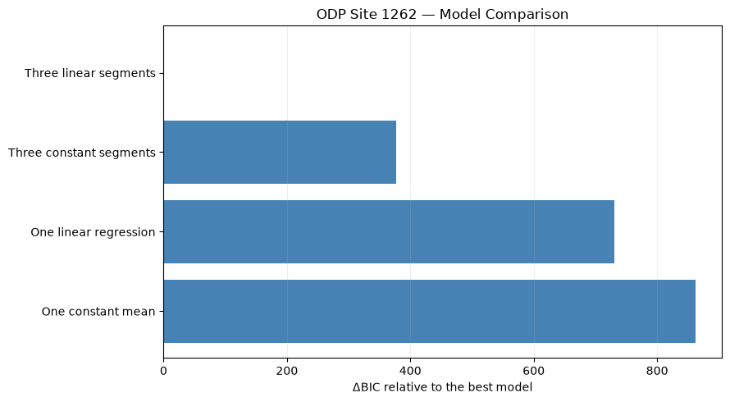
Figure S 1: BIC comparison of candidate models
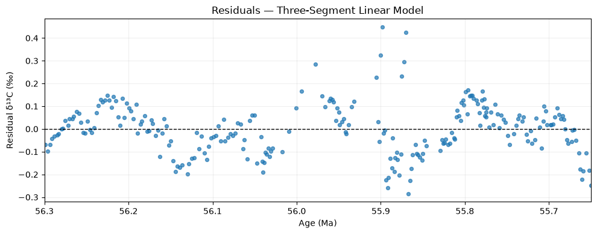
Figure S 2: Residuals of the three-segment linear model
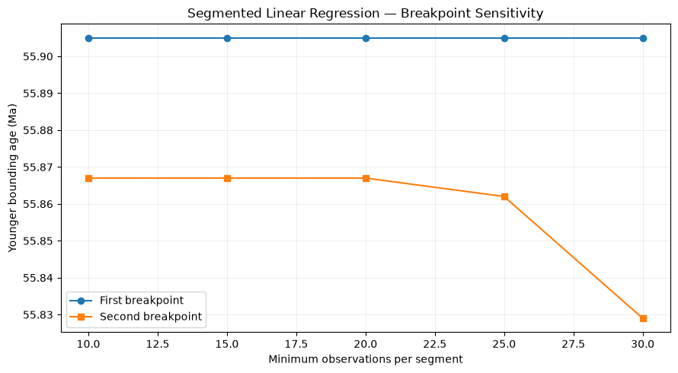
Figure S 3: Breakpoint sensitivity to minimum segment size

Table S 1: Model comparison statistics
model | rss | parameters | bic | delta_bic
Three linear segments | 3.037507 | 8 | -1042.32 | 0
Three constant segments | 14.9679 | 5 | -664.913 | 377.405
One linear regression | 67.01995 | 2 | -311.168 | 731.1502
One constant mean | 116.2916 | 1 | -180.553 | 861.765
Table S 2: Residual autocorrelation
segment | n | lag1_autocorrelation
Older | 125 | 0.7992092276917813
Middle | 22 | 0.6291887030556018
Younger | 100 | 0.8648147560591458

Table S 3: Breakpoint sensitivity
min_segment | rss | first_older_ma | first_younger_ma | second_older_ma | second_younger_ma
10 | 3.037507 | 55.932 | 55.905 | 55.87 | 55.867
15 | 3.037507 | 55.932 | 55.905 | 55.87 | 55.867
20 | 3.037507 | 55.932 | 55.905 | 55.87 | 55.867
25 | 4.027855 | 55.932 | 55.905 | 55.864 | 55.862
30 | 4.481729 | 55.932 | 55.905 | 55.846 | 55.829

